Task 2

Sentiment Analysis using ML and DL

Project Report
Redg. No. INBT021871 | Course ID: AIINB10726 | Prepared by:Avni Shukla

1. Objective
Part A: Use traditional machine learning (TF-IDF + Logistic Regression + SVM) to perform sentiment/emotion analysis on a text dataset, establishing a classical baseline.
Part B: Implement an LSTM deep learning model and fairly compare it against the classical models from Part A, using the exact same train/test split and evaluation metrics.

2. Preprocessing Explanation

2.1 Data Cleaning
- Lowercasing — all text converted to lowercase for consistency.
- Punctuation removal — all punctuation characters stripped using Python's string.punctuation table.
- Number removal — digit characters removed from the text.
- Emoji / non-ASCII removal — characters outside the ASCII range dropped.
- Extra whitespace removal — repeated/leading/trailing spaces collapsed to single spaces.

2.2 Tokenization
Cleaned text is split into individual word tokens using NLTK's word_tokenize, which handles punctuation-aware splitting more reliably than a plain .split().

2.3 Stopword Removal
Common English stopwords (from NLTK's stopword corpus, e.g. "the", "is", "and") are removed from the token list, since they carry little sentiment-discriminating information. The remaining tokens are re-joined into the final cleaned text used for feature extraction.

2.4 Class Distribution
Before modeling, the class distribution of the emotion labels is computed and plotted. Because the dataset is imbalanced across emotion classes, macro-averaged F1-score (rather than raw accuracy) is used as the primary metric throughout Part A and Part B, since it weights all classes equally regardless of their size.

2.5 Fixed Train/Test Split
A single train_test_split call with test_size=0.20, random_state=42, and stratification by label is used to create the train/test sets. This exact split is reused unchanged for TF-IDF (Logistic Regression, SVM) and for the LSTM, so all three models are evaluated on identical, comparable data.

3. Architecture Diagrams

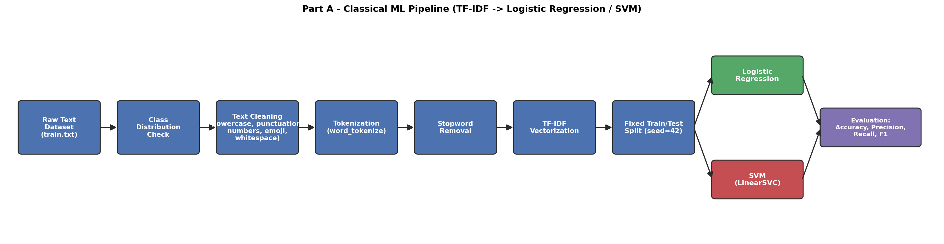
3.1 Part A — Classical ML Pipeline

3.2 Part B — LSTM Architecture
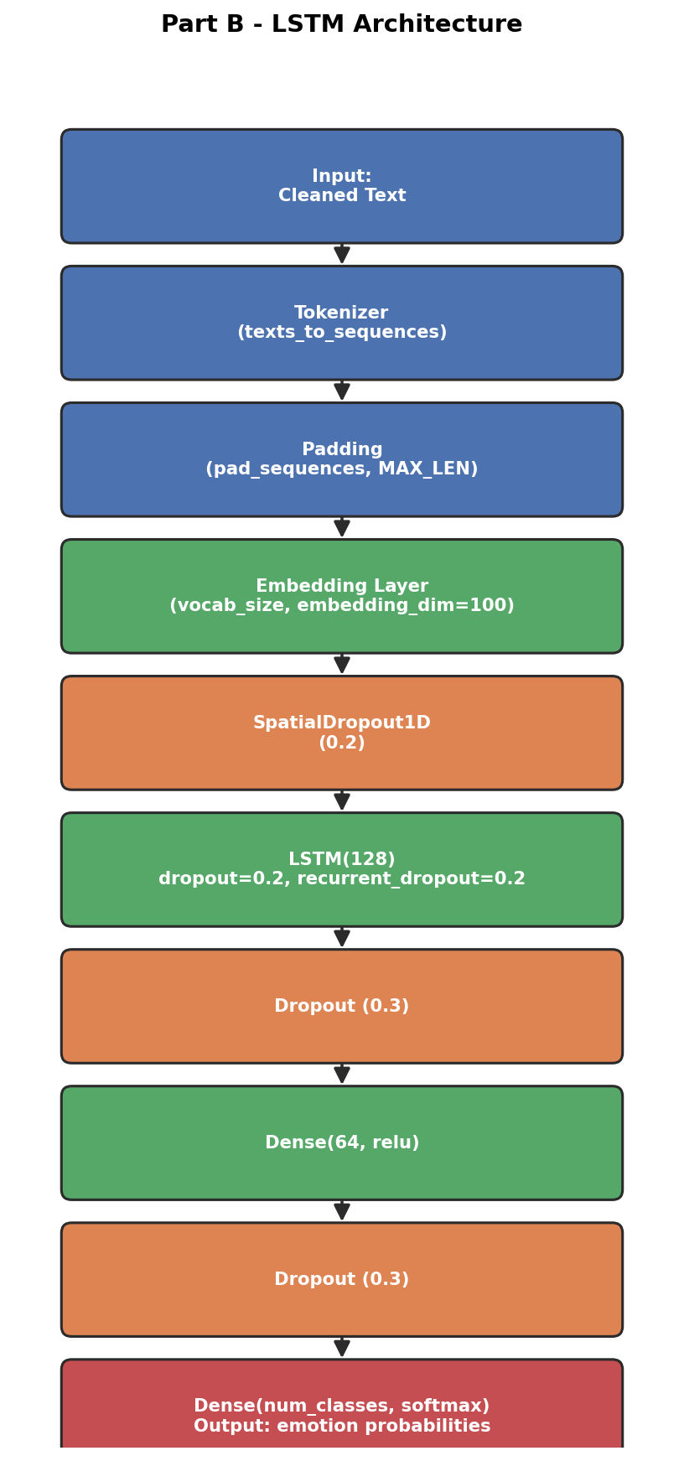

4. Performance Table — Logistic Regression vs SVM vs LSTM

Model | Accuracy | Precision (macro) | Recall (macro) | F1-score (macro)
Logistic Regression | 0.8509 | 0.8680 | 0.7427 | 0.7872
SVM (LinearSVC) | 0.8869 | 0.8750 | 0.8344 | 0.8527
LSTM | 0.8788 | 0.8251 | 0.8314 | 0.8240

5. Metric Comparison and Confusion Matrices

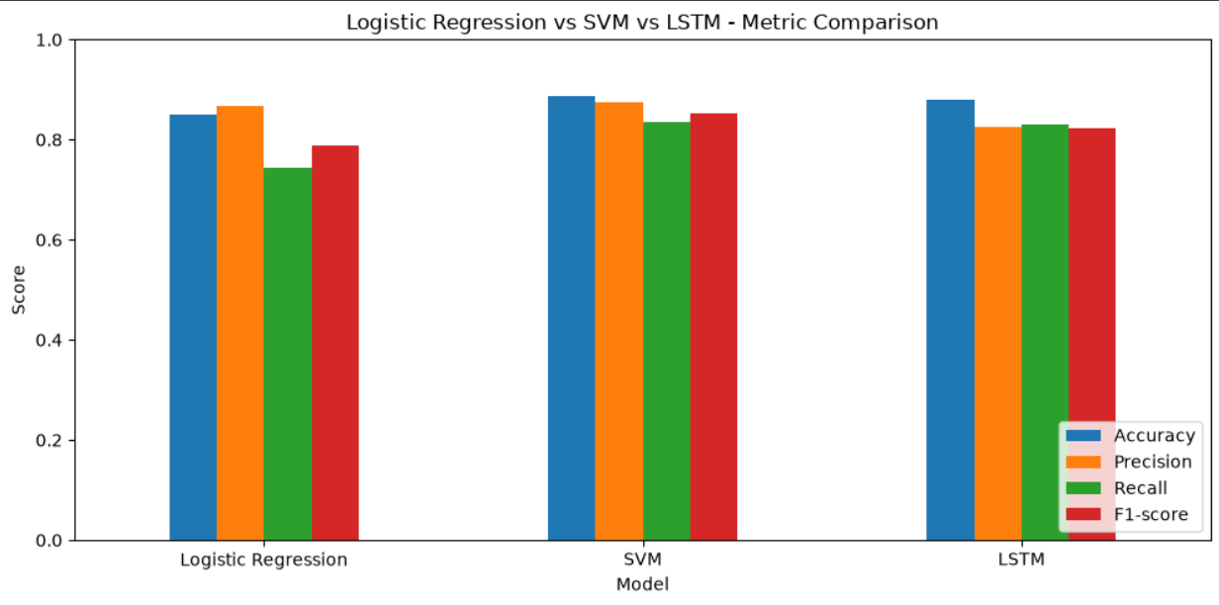

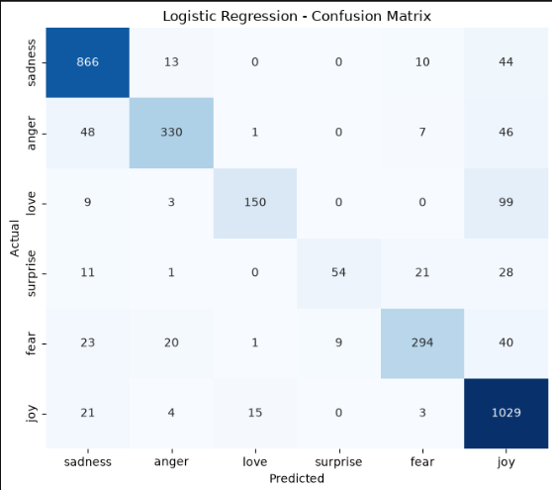

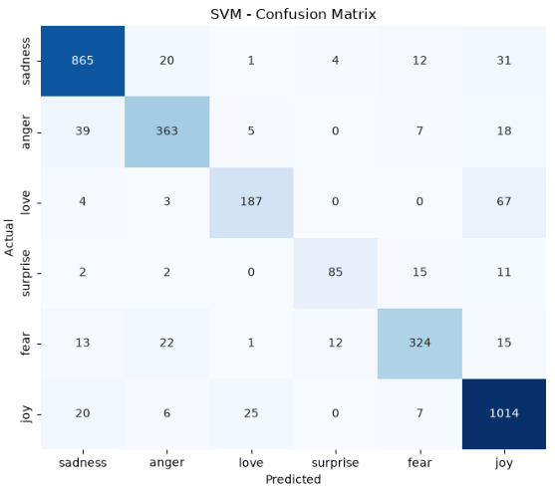

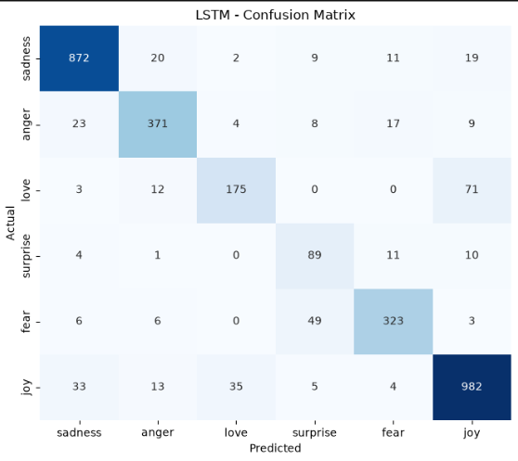

6. Discussion

6.1 Why LSTM is Suitable for Text Data
Text is inherently sequential — the meaning of a word depends on the words around and before it (e.g. negation: "not good" vs. "good"). Unlike TF-IDF-based classical models, which treat text as an unordered bag of weighted word frequencies, an LSTM processes tokens in order and maintains a hidden state that carries context forward, so it can in principle capture word order, negation, and longer-range dependencies that TF-IDF discards.

6.2 How Sequential Learning Helps Sentiment Analysis
Sentiment is often modified or flipped by context ("not bad at all", "used to love it but..."). A recurrent model like LSTM updates its internal state token by token, so it can pick up on such patterns as they unfold across a sentence, whereas a bag-of-words model sees "not" and "bad" as independent, order-less features.

6.3 Whether LSTM Improved Performance
LSTM did NOT beat the best classical model (behind by 0.0287 F1 points).

6.4 Why LSTM Did Not Beat the Classical Models ?
- Dataset size: LSTMs learn word embeddings and sequence patterns from scratch and are data-hungry; with only a few thousand short training examples there may not be enough data to learn a rich embedding space, whereas TF-IDF + Logistic Regression/SVM already gets strong, sample-efficient signal directly from word-presence weighting.
- Short, simple text: emotion-labelled sentences here tend to be short and lexically direct (a few strongly emotion-indicative words are usually enough), so the extra sequence-modeling capacity of an LSTM may not pay off.
- Training time / tuning budget: LSTMs typically need more epochs and careful hyperparameter tuning to reach their full potential; with a modest epoch budget and default hyperparameters, an LSTM often underperforms a well-tuned linear baseline.
- Insufficient data for deep learning to show its advantage: the theoretical strength of LSTMs , modeling long-range dependencies and word order — pays off most on longer, more syntactically complex text; on short, single-sentence inputs that advantage shrinks.
Recognizing when a simpler model wins is a key data-science skill , it is a valid, reportable outcome if the classical models match or beat the LSTM here, and does not indicate a flawed implementation.

6.5 Challenges Faced During Training
- Choosing MAX_LEN and vocabulary size (VOCAB_SIZE): too small truncates useful context, too large adds sparse, mostly-padding input.
- Overfitting: LSTMs have many parameters relative to a small dataset, so dropout, recurrent dropout, and early stopping were needed to keep validation loss from diverging from training loss.
- Class imbalance affects the LSTM the same way it affects the classical models, macro F1 is used here too so it is not judged on accuracy alone.
- Longer training time per epoch compared to the classical models, for a comparatively small (or negative) accuracy gain in this case.

7. Conclusion
The final recommended model for this task based on the performance table is Classical Model SVM with F1 score : 0.8527.

